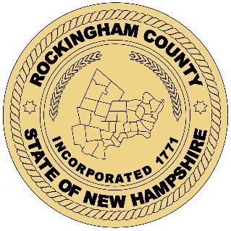Rockingham County Commissioners

119 North Road
Brentwood, NH 03833

Notice of Attendance
A majority of the Rockingham County Commissioners will be attending the following events at the below dates, times, and locations:

Rockingham County Convention Meeting
September 27, 2021
6:00 p.m. – 9:00 p.m.
Hilton Auditorium 117 North Rd
Brentwood, NH 03833

Posted September 13, 2021 @ 3:50 pm

